CHAPTER 3

ISDN (integrated services digital Network)

3.1 What is ISDN?
The Integrated Services Digital Network (ISDN) is a set of international standards for access to advanced, all-digital public telecommunications networks. The key elements of this definition are:
- Integrated Services
  - Voice
  - Video
  - Image
  - Data
  - Mixed media at a number of standard data rates
- Digital
  - Digital terminal equipment
  - Digital local loops
  - Digital trunks
  - Digital switching
  - Digital signaling
- Network
  - Worldwide, interoperating communications fabric under distributed control using common standards
ISDN standards have been defined by the ITU-T, a branch of the United Nations' International Telecommunications Union (ITU), in the series I and Q recommendations.

Integrated Services . . .
The current telephone network uses a mixture of analog and digital transmission methods and diverse access techniques and standards to provide different services:
- Switched voice telephony
- Centrex
- Dedicated point-to-point data carrier
- Packet-switched data carrier
- Dedicated point-to-point digital carrier
Future telephone networks will also provide full-motion video, voice/video/graphics conferencing, high-speed facsimile, and electronic mail.
ISDN integrates all these services by providing a small set of standard interfaces and access protocols that apply to all services. Because ISDN is an international standard, the same interfaces and access protocols should be available anywhere in the world, across international boundaries, and among equipment from any set of vendors.
3.10.3 ISDN Protocol Architecture

Figure AS illustrates, in the context of the OSI model, the protocols defined or referenced in the ISDN documents. As a network, ISDN is essentially unconcerned with user layers 4-7. These are end-to-end layers employed by the user for the exchange of information. Network access is concerned only with layers 1-3. Layer 1, defined in 1.430 and 1.431, specifies the physical interface for both basic and primary access. Because B and D channels are multiplexed over the same physical interface, these standards apply to both types of channels. Above this layer, the protocol structure differs for the two channels.
For the D channel, a new data link layer standard, LAPD (Link Access Protocol, D channel) has been defined. This standard is based on HDLC, modified to meet ISDN requirements. All transmission on the D channel is in the form of LAPD frames that are exchanged between the subscriber equipment and an ISDN switching element. Three applications are supported: control signaling, packetswitching,
and telemetry. For control signaling, a call control protocol has been defined (1.451lQ.931). This protocol is used to establish, maintain, and terminate connections on B channels; thus, it is a protocol between the user and the network. Above layer 3, there is the possibility for higher-layer functions associated with user-to-user control signaling. These functions are a subject for further study. The
D channel can also be used to provide packet-switching services to the subscriber. In this case, the X.25 level-3 protocol is used, and X.25 packets are transmitted in LAPD frames. The X.25 level-3 protocol is used to establish virtual circuits on the D channel to other users and to exchange packetized data. The final application area, telemetry, is a subject for further study.

The B channel can be used for circuit switching, semipermanent circuits, and packet-switching. For circuit switching, a circuit is set up on a B channel, on demand. The D-channel call control protocol is used for this purpose. Once the circuit is set up, it may be used for data transfer between the users. A semipermanent circuit is a B-channel circuit that is set up by prior agreement between the connected users and the network. As with a circuit-switched connection, it provides a transparent data path between end systems.

With either a circuit-switched connection or a semipermanent circuit, it appears to the connected stations that they have a direct, full-duplex link with each other. They are free to use their own formats, protocols, and frame synchronization. Hence, from the point of view of ISDN, layers 2 through 7 are not visible or specified.

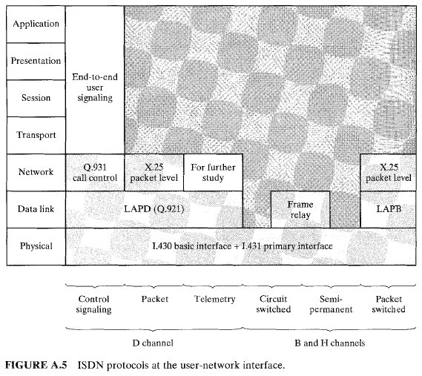
In the case of packet-switching, a circuit-switched connection is set up on a B channel between the user and a packet-switched node using the D-channel control protocol. Once the circuit is set up on the B channel, the user may employ X.25 layers 2 and 3 to establish a virtual circuit to another user over that channel and to exchange packetized data. As an alternative, the frame relay service may be used.
Frame relay can also be used over H channels and over the D channel.

Some of the protocols shown in Figure A.5 are summarized in the remainder of this section. First, we look at the way in which packet-switched and circuitswitched connections are set up. Next, we xamine the control-signaling protocol and then LAPD. Finally, the physical-layer specifications are reviewed.

3.2 Components of ISDN
While individual operating companies and ministries will define the specific services, within the ISDN architecture the ITU standards define a number of component parts and functions:
- ISDN CHANNELS
- ACCESS TYPES
- DEVICES
- INTERFACES
- PROTOCOLS

ISDN Channels
A CHANNEL is the basic unit of ISDN service. The ISDN Standards define three basic types of channels:
- Bearer channels (B channels)
- Delta (or "Demand") channels (D channels)
- High-capacity channels (H channels)

B Channel
A B channel is a 64-Kbps unit of clear digital bandwidth. Based on the data rate required to carry one digital voice conversation, a B channel can carry any type of digital information (voice, data, or video) with no restrictions on format or protocol imposed by the ISDN carrier.

D Channel
A D channel is a signalling channel. It carries the information needed to connect or disconnect calls and to negotiate special calling parameters (i.e., automatic number ID, call waiting, data protocol). The D channel can also carry packet-switched data using the X.25 protocol.
The D channel is not a clear channel. It operates according to a well-defined pair of layered protocols:
- Q.921 (LAPD) at the Data Link Layer (Layer 2)
- Q.931 at the upper layers (Layers 3 and above)
The data rate of a D channel varies according to the type of access it serves: a Basic Rate Access D channel operates at 16 Kbps and a Primary Rate Access D channel operates at 64 Kbps.

Signalling on the D Channel
The ISDN D channel carries all signalling between the customer's terminal device and the carrier's end switching office.
Signalling information with end-to-end significance (i.e., which must be received by the terminal device at a call's destination, such as Automatic Calling Number Identification information) travels between the carrier's switching offices on the carrier's common-channel signalling network and on to the destination terminal through the receiving user's D channel.

H Channel
An H channel is a special, high-speed clear channel. H channels, designed primarily for full-motion color video, are not yet in common use. There are currently three kinds of H channel:
- H0 ("H-zero")
- H11 ("H-one-one")
- H12 ("H-one-two")
An H0 channel operates at 384 Kbps (roughly one fourth of a North American Primary Rate Access or one fifth of a European Primary Rate Access). An H1 channel operates at 1.536 Mbps and occupies one whole North American Primary Rate Access. An H12 channel occupies an entire European Primary Rate Access.

3.3 ISDN Access Types
ISDN offers two general types of access:
- BASIC RATE ACCESS (BRA)
- PRIMARY RATE ACCESS (PRA)
These differ from one another by the amount of information they can carry.

3.3.1 Basic Rate Access
Basic Rate Access is based on new technology conceived especially for ISDN. Designed to provide service to individual users or small businesses, Basic Rate Access provides two 64-Kbps B channels and one 16-Kbps D channel (referred to as 2B+D). In other words, it provides transmission facilities for one voice conversation (one B channel), one medium-speed data session (the other B channel), and the signalling exchanges needed to make them work (the D channel).
Two B channels at 64 Kbps plus one D channel at 16 Kbps equals 144K bps. The ISDN Basic Rate transmission protocol uses an additional 48 Kbps of bandwidth for maintenance and synchronization, so an ISDN Basic Rate Access actually uses 192 Kbps.
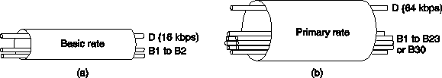
Fig. 2-42. (a) Basic rate digital pipe. (b) Primary rate digital pipe

3.3.2Primary Rate Access
Primary Rate Access, which is based on pre-ISDN digital carrier technology, is designed to provide high-capacity service to large customers for applications such as PBX-to-PBX trunking. There are two kinds of Primary Rate Access: 23B+D and 30B+D. Each depends on the kind of digital carrier available in a given country.
In North America and Japan, 23B+D Primary Rate Access operates at 1.544 Mbps and offers 23 B channels plus 1 64-Kbps D channel (usually located in time-slot 23), or 4 H0 channels, or 1 H11 channel. In most of the rest of the world, 30B+D Primary Rate Access operates at 2.048 Mbps and offers 30 B channels plus 1 64-Kbps D channel (located in time-slot 16), or 5 H0 channels, or 1 H12 channel.

3.4 ISDN Devices
In the context of ISDN standards, STANDARD DEVICES refers not to actual hardware, but to standard collections of functions that can usually be performed by individual hardware units. The ISDN Standard Devices are:
- Terminal Equipment (TE)
- Terminal Adapter (TA)
- Network Termination 1 (NT1)
- Network Termination 2 (NT2)
- Exchange Termination (ET)

Terminal Equipment (TE)
A TE is any piece of communicating equipment that complies with the ISDN standards. Examples include: digital telephones, ISDN data terminals, Group IV Fax machines, and ISDN-equipped computers.
In most cases, a TE should be able to provide a full Basic Rate Access (2B+D), although some TEs may use only 1B+D or even only a D channel.

Terminal Adapter (TA)
A TA is a special interface-conversion device that allows communicating devices that don't conform to ISDN standards to communicate over the ISDN.
The most common TAs provide Basic Rate Access and have one RJ-type modular jack for voice and one RS-232 or V.35 connector for data (with each port able to connect to either of the available B channels). Some TAs have a separate data connector for the D channel.
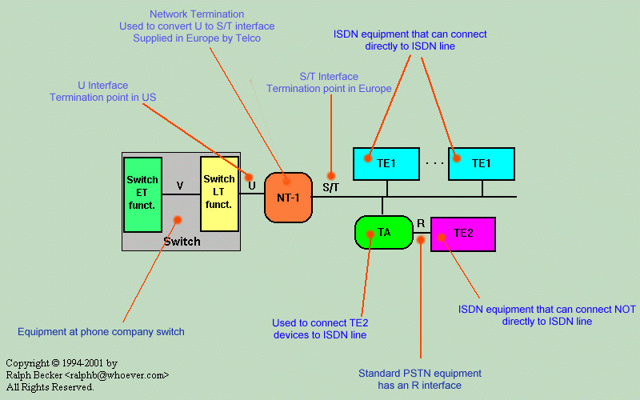

Network Termination (NT1 and NT2)
The NT devices, NT1 and NT2, form the physical and logical boundary between the customer's premises and the carrier's network. NT1 performs the logical interface functions of switching and local-device control (local signalling). NT2 performs the physical interface conversion between the dissimilar customer and network sides of the interface.
In most cases, a single device, such as a PBX or digital multiplexer, performs both physical and logical interface functions. In ISDN terms, such a device is called NT12 ("NT-one-two") or simply NT.

Exchange Termination (ET)
The ET forms the physical and logical boundary between the digital local loop and the carrier's switching office. It performs the same functions at the end office that the NT performs at the customer's premises.
In addition, the ET:
- Separates the B channels, placing them on the proper interoffice trunks to their ultimate destinations
- Terminates the signalling path of the customer's D channel, converting any necessary end-to-end signalling from the ISDN D-channel signalling protocol to the carrier's switch-to- switch trunk signalling protocol

3.5 ISDN Interfaces (Standard Reference Points)
The ISDN standards specify four distinct interfaces in the customer's connection to the network: R, S, T, and U.
From the standards viewpoint, these are not "real" physical interfaces, but simply STANDARD REFERENCE POINTS where physical interfaces may be necessary. However, in common practice, the names of reference points are used to refer to physical interfaces.

The R Interface
The interface at reference point R is the physical and logical interface between a non-ISDN terminal device and a terminal adapter (TA). The R interface is not really part of the ISDN; it can conform to any of the common telephone or data interface standards.

The S Interface
The interface at reference point S is the physical and logical interface between a TE (or TA) and an NT. The S interface uses four wires and employs a bipolar transmission technique known as Alternate Mark Inversion (AMI).
A special feature of the S interface is the "Short Passive Bus" configuration, which allows up to eight ISDN devices (TE or TA) to contend for packet access to the D channel in a prioritized, round-robin fashion. Only one device at a time can use a given B channel.

The T Interface
The interface at reference point T is the physical and logical interface between NT1 and NT2, whenever the two NTs are implemented as separate pieces of hardware. The specification for the T interface is identical to the specification for the S interface.
In most implementations, NT1 and NT2 exist in the same physical device, so there is no real T interface.

The U Interface
The interface at reference point U is the physical and logical interface between NT (or NT2) and the ISDN carrier's local transmission loop. It is also the legal demarcation between the carrier's loop and the customer's premises.
The U interface is implemented with two wires and uses a special quaternary signal format (i.e., four possible electrical states, with one pulse encoding a predefined combination of 2 bits) called 2B1Q. Quaternary encoding allows the U interface to carry data with a logical bit rate of 192 Kbps over a signal with a physical pulse rate of only 96 Kbps. The slower pulse rate is better suited to the less-predictable environment of the outside-plant loop carrier system.

3.10.2 ISDN System Architecture
The key idea behind ISDN is that of the digital bit pipe between the customer and the carrier through which bits flow in both directions. Whether the bits originate from a digital telephone, a digital terminal, a digital facsimile machine, or some other device is irrelevant.
The digital bit pipe can support multiple independent channels by time division multiplexing of the bit stream. Two principal standards for the bit pipe have been developed:
- a low bandwidth standard for home use, and
- a higher bandwidth standard for business use that supports multiple channels identical to the home use channels.
Normal configuration for a home consists of a network terminating device NT1 (Fig. 2-41(a)) placed on the customer's premises and connected to the ISDN exchange in the carrier's office using the twisted pair previously used to connect the telephone. The NT1 box has a connector into which a bus cable can be inserted. Up to 8 ISDN telephones, terminals, alarms, and other devices can be connected to the cable. From the customer's point of view, the network boundary is the connector on NT1.
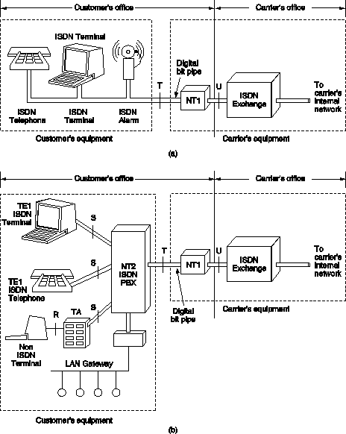
Fig. 2-41. (a) Example ISDN system for home use. (b) Example ISDN system
with a PBX for use in large businesses
For large businesses, the model of Fig. 2-41(b) is used. There is a device NT2 called PBX (Private Branch eXchange - conceptually the same as an ISDN switch) there connected to NT1 and providing the interface for ISDN devices.
CCITT defined four reference points (Fig. 2-41):
- U reference point = connection between the ISDN exchange and NT1,
- T reference point = connector on NT1 to the customer,
- S reference point = interface between the ISDN PBX and the ISDN terminal,
- R reference point = the connection between the terminal adapter and non-ISDN terminal.

3.13 BROADBAND ISDN

In 1988, as part of its I-series of recommendations on ISDN, CCITT issued the first two recommendations relating to broadband (B-ISDN): 1.113, Vocabulary of Terms for Broadband Aspects of ISDN; and 1.121, Broadband Aspects of ISDN. These documents provided a preliminary description and a basis for future standardization and development work, and from those documents a rich set of recommendations has been developed. Some of the important notions developed in these
documents are presented in Table A.5.

TABLE A.5 Noteworthy statements in 1.113 and 1.121
Broadband: A service or a system requiring transmission channels capable of supporting rates greater than the primary rate.

The term B-ISDN is used for convenience in order to refer to and emphasize the broadband aspects of ISDN. The intent, however, is that there be one comprehensive notion of an ISDN which provides broadband and other ISDN services.
Asynchronous transfer mode (ATM) is the transfer mode for implementing B-ISDN and is independent of the means of transport at the Physical Layer.
B-ISDN will be based on the concepts developed for ISDN and may evolve by progressively incorporating directly into the network additional B-ISDN functions enabling new and advanced services.
Since the B-ISDN is based on overall ISDN concepts, the ISDN access reference configuration is also the basis for the B-ISDN reference configuration.

CCITT modestly defines B-ISDN as "a service requiring transmission channels cable of supporting rates greater than the primary rate." Behind this innocuous statement lie plans for a network and a set of services that will have far more impact on business and residential customers than ISDN. With B-ISDN, services, especially video services, requiring data rates in excess of those that can be delivered
by ISDN will become available. To contrast this new network and these new services to the original concept of ISDN, that original concept is now being referred to as narrowband ISDN.

3.13.1 Broadband ISDN Architecture

B-ISDN differs from a narrowband ISDN in a number of ways. To meet the requirement for high-resolution video, an upper channel rate of approximately 150 Mbps is needed. To simultaneously support one or more interactive and distributive services, a total subscriber line rate of about 600 Mbps is needed. In terms of today's installed telephone plant, this is a stupendous data rate to sustain. The only appropriate technology for widespread support of such data rates is optical fiber. Hence, the introduction of B-ISDN depends on the pace of introduction of fiber subscriber loops.
Internal to the network, there is the issue of the switching technique to be used. The switching facility has to be capable of handling a wide range of different bit rates and traffic parameters (e.g., burstiness). Despite the increasing power of digital circuit-switching hardware and the increasing use of optical fiber trunking, it is difficult to handle the large and diverse requirements of B-ISDN with circuitswitching technology. For this reason, there is increasing interest in some type of fast packet-switching as the basic switching technique for B-ISDN. This form of switching readily supports ATM at the user-network interface.

3.13.2 Functional Architecture

Figure A.12 depicts the functional architecture of B-ISDN. As with narrowband ISDN, control of B-ISDN is based on common-channel signaling. Within the network, an SS7, enhanced to support the expanded capabilities of a higher-speed network, is used. Similarly, the user-network control-signaling protocol is an enhanced version of I.451lQ.931.
B-ISDN must, of course, support all of the 64-kbps transmission services, both circuit-switching and packet-switching, that are supported by narrowband ISDN;
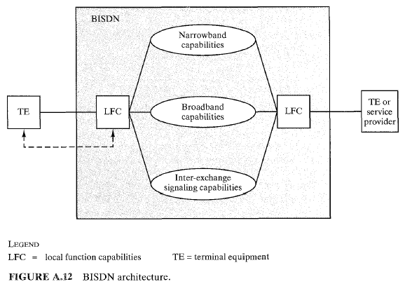
this protects the user's investment and facilitates migration from narrowband to broadband ISDN. In addition, broadband capabilities are provided for higher datarate transmission services. At the user-network interface, these capabilities will be provided with the connection-oriented asynchronous transfer mode (ATM) facility.

User-Network Interface

The reference configuration defined for narrowband ISDN is considered general enough to be used for B-ISDN. Figure A.13, which is almost identical to Figure A.4, shows the reference configuration for B-ISDN. In order to clearly illustrate the broadband aspects, the notations for reference points and functional groupings are appended with the letter B (e.g., B-NT1, TB). The broadband functional groups are equivalent to the functional groups defined for narrowband ISDN, and are discussed below. Interfaces at the R reference point may or may not have broadband capabilities.

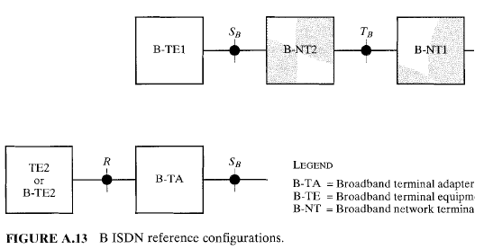

3.13.4 Transmission Structure

In terms of data rates available to B-ISDN subscribers, three new transmission services
are defined. The first of these consists of a full-duplex 155.52-Mbps service. The second service defined is asymmetrical, providing transmission from the subscriber to the network at 155.52 Mbps, and in the other direction at 622.08 Mbps; and the highest-capacity service yet defined is a full-duplex, 622.08-Mbps service.
A data rate of 155.52 Mbps can certainly support all of the narrowband ISDN services. That is, such a rate readily supports one or more basic- or primary-rate interfaces; in addition, it can support most of the B-ISDN services. At that rate, one or several video channels can be supported, depending on the video resolution and the coding technique used. Thus, the full-duplex 155.52-Mbps service will probably be the most common B-ISDN service.
The higher data rate of 622.08 Mbps is needed to handle multiple video distribution, such as might be required when a business conducts multiple simultaneous videoconferences. This data rate makes sense in the network-to-subscriber direction. The typical subscriber will not initiate distribution services and thus would still be able to use the lower, 155.52-Mbps service. The full-duplex, 622.08-
Mbps service would be appropriate for a video-distribution provider.

3.13.5 Broadband ISDN Protocols

The protocol architecture for B-ISDN introduces some new elements not found in the ISDN architecture, as depicted in Figure A.14. For B-ISDN, it is assumed that the transfer of information across the user-network interface will use ATM.
The decision to use ATM for B-ISDN is a remarkable one; it implies that B-ISDN will be a packet-based network, certainly at the interface, and almost certainly in terms of its internal switching. Although the recommendation also states that B-ISDN will support circuit-mode applications, this will be done over a packetbased transport mechanism. Thus, ISDN, which began as an evolution from the
circuit-switching telephone network, will transform itself into a packet-switching network as it takes on broadband services.
The protocol reference model makes reference to three separate planes:
- User Plane. Provides for user-information transfer, along with associated controls (e.g., flow control, error control).
- Control Plane. Performs call-control and connection-control functions.
- 9Management Plane. Includes plane management, which performs management functions related to a system as a whole and provides coordination between all the planes, and layer management, which performs management functions relating to resources and parameters residing in its protocol entities.

Table A.6 highlights the functions to be performed at each sublayer.

